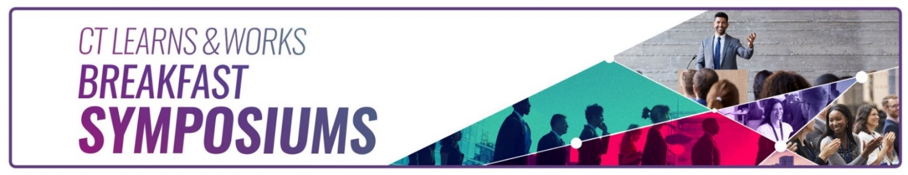
CT Learns and Works – Spring 2024 Breakfast Symposium

Founders Hall at CT State Community College Naugatuck Valley, Waterbury
Friday, April 5, 2024

Mosaic of pathways to high-paying jobs...
Agenda

7:30 a.m. Registration and Networking Breakfast

8:00 a.m. Opening and Welcome Remarks
Danté Bartolomeo, Commissioner, CT Department of Labor
Sarah E. Gager, Dean of Student Services, CT State Community College – Naugatuck Valley

8:15 – 8:40 a.m. Keynote - Paul Lavoie, Chief Manufacturing Officer for Connecticut

8:45 – 9:30 a.m. Panel Moderator: Lawrence Pomerleau - Alternative Training Programs - Manufacturing
Christine Marcin, President, Women in Manufacturing (WIM)
Cyndi Zoldy, Executive Director, Manufacturing Alliance Service Corporation (MASC)
Sharon Lutkus, Interim Director of Advanced Mfg. & Welding, CT State NV

9:30 – 10:00 a.m. Panel Moderator: Lawrence Pomerleau - Manufacturing - Employer Perspective
Tim Fox – Director, SENEDIA
Willie Barber, Youth Education & Outreach Lead at General Dynamics Electric Boat

10:00 -10:15 a.m. Coffee Break

10:15-10:45 a.m. Current Labor Market Information
Patrick Flaherty, Research Director, CT DOL Office of Research

10:45 -11:30 a.m. Health and Tech Opportunities

Accenture’s Entry-Level Earn-and-Learn Program
Carol Quinn Toomey, Managing Director, Accenture

Healthcare Careers
Andrew Rennie, Account Executive & Business Development Representative – AMR

Opportunities in Healthcare
Saint Mary’s Hospital, Waterbury

11:30 a.m. Closing Remarks

Free registration includes breakfast and a morning of lively discussions and networking. Email ccrn@ct.gov if you have questions.

https://www.eventbrite.com/e/ct-learns-and-works-spring-2024-breakfast-symposium-tickets-850870866667
Please turn over to learn more about the presenters…

